Reach PoE5 Tester Control Card Revision A Upgrade
Reach PN: 41-0040-0B
Revision A/01 and Revision A/02

August 24, 2021

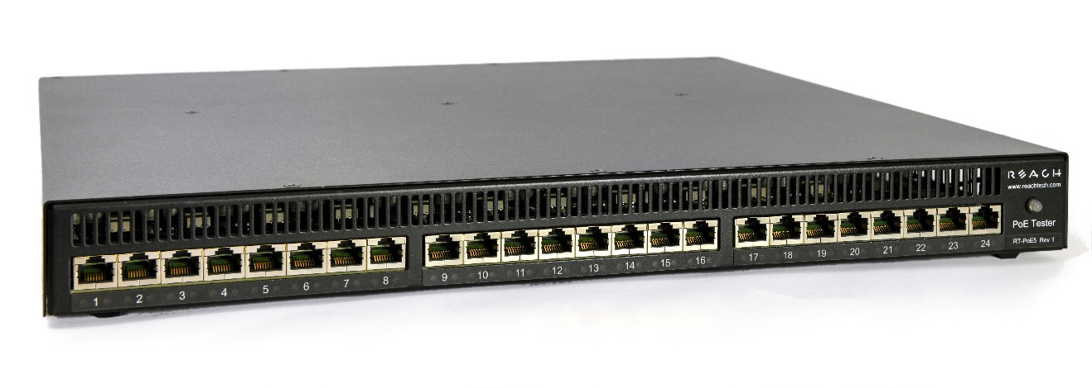

© 2021 Reach Technology, part of Novanta
All Rights Reserved

NOTE: The information contained in this user documentation is subject to change without notice and does not represent a commitment on the part of Reach Technology. Reach Technology assumes no responsibility or liability for any errors or inaccuracies that may appear in this user documentation.

Reach Technology
www.reachtech.com
Sales
503-675-6464 ext. 2
sales@reachtech.com

Support
503-675-6464 ext. 1
techsupport@reachtech.com
Table of Contents
1. Identifying a Revision “A” Control Card 3
2. Determining Condition of a Revision “A” Control Card 4
2.1. Equipment Needed 4
2.2. Verifying Rear Fan Operation 4
3. Upgrading the PoE5 Firmware 5
4. Requesting an Upgrade Kit 5
5. Requesting a Return Merchandise Authorization (RMA) 5
6. Replacing the Control Card Revision “A” to Revision “B” 6
6.1. Tools Required 6
6.2. Parts Required 6
6.3. Removing the Top Cover 6
6.4. Marking the Line Card Cables 9
6.5. Disconnecting the Control Card Cables 9
6.6. Removing the Control Card Screws 9
6.7. Inserting the Revision “B” Control Card 10
6.8. Installing the Baffle Plate 11
6.9. Connecting the Cables 11
6.10. Installing the Top Cover 12

Identifying a Revision “A” Control Card

When viewing the PoE5 Tester from the front, where the ethernet ports are located, the right side of the unit has visibility of the PN: 41-0040-0B Control Card Revision as shown in Picture 1.1:

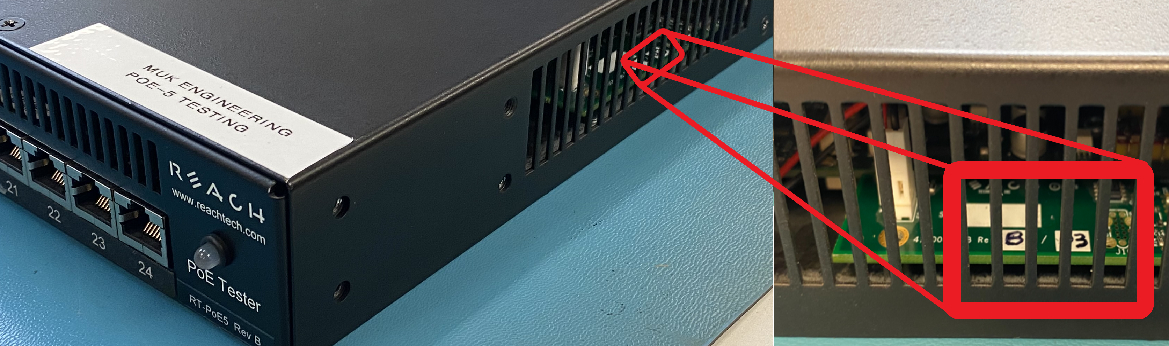
Picture 1.1 Control Card Revision Location

If the visible Revision of a Control Card contains “A/xx”, please continue to the next section to determine what state of operation the Control Card is in to determine the appropriate next steps.

Determining Condition of a Revision “A” Control Card

The goal of this section is to determine whether the fan control circuit MOSFET (Q1) has been damaged on the Revision A/xx Control Card.

Equipment Needed
- PoE5 Tester 138W Power Supply (Reach PN: 30-0015-01)
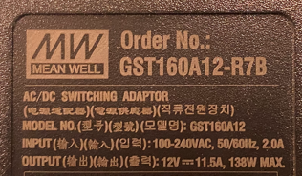
Picture 2.1 PoE5 Power Supply

Verifying Rear Fan Operation
When connecting a PoE5 Tester to a power supply, the PoE5 Tester software will kick on the rear fans at an increased speed before returning to an idle fan speed condition. If fan operation is unable to be determined in an idle state, disconnect the power supply from the rear connector and reconnect the power supply to the power connector as shown in Picture 2.

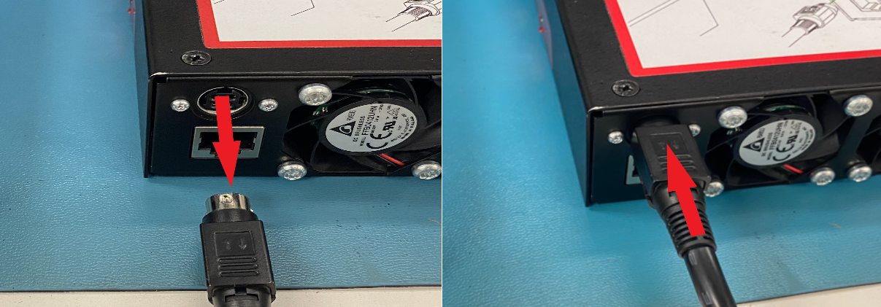
Picture 2.2 Rebooting the Unit

After reconnecting the power supply connector to the unit, the fans should turn ON, emitting an audible whine and a burst of airflow from the rear of the unit. Check the results of the fan operation verification for guidance on next steps in Table 2.2.
Fan Operation | Next Steps
ON – Working | See Section 3
OFF – Not Working | See Section 5

Table 2.2 Fan Condition Next Steps

Upgrading the PoE5 Firmware to V1.1.1

Need a link and callouts for the software to be used for updating as well as a location/reference to the “RT-PoE5 Firmware Update” manual that already exists, but couldn’t find online…

Requesting an Upgrade Kit

Please email service@ReachTech.com to request a Revision “B/03” Control Card Upgrade Kit.

WARNING – PoE5 Tester serial number identification will be required to be approved for the upgraded Revision “B/03” Control Card. Only one Control Card Upgrade Kit will be provided per serial number.

Requesting a Return Merchandise Authorization (RMA)

Please email service@ReachTech.com for an RMA number to be assigned for returning a unit with fan operation issues.

WARNING – Reach will not accept units shipped to our facility without an approved RMA number Packages received without an RMA number may be returned to the sender.

Replacing the Control Card Revision “A” to Revision “B”

Once the Revision “B” Control Card has been received, removal and replacement of the Revision “A” Control Card can be accomplished using the procedural steps covered in the following sections.

Tools Required

- Black Marker
- Red Marker
- #1 Phillips Screwdriver

Parts Required

- Reach PN: 41-0040-0B Revision “B/03”

Removing the Top Cover

Use a #1 Phillips Screwdriver to remove the 10 screws (PN: 22-0126-00) from the top of the unit showing in Picture 6.1.

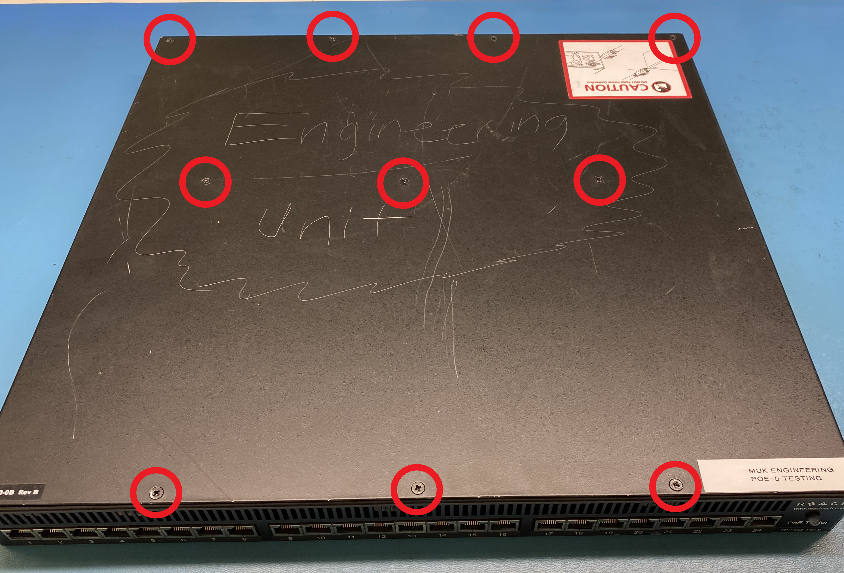
Picture 6.1 Top Cover Screw Locations

Remove the 2 screws (PN: 22-0126-00) from the right side of the top cover shown in Picture 6.2.

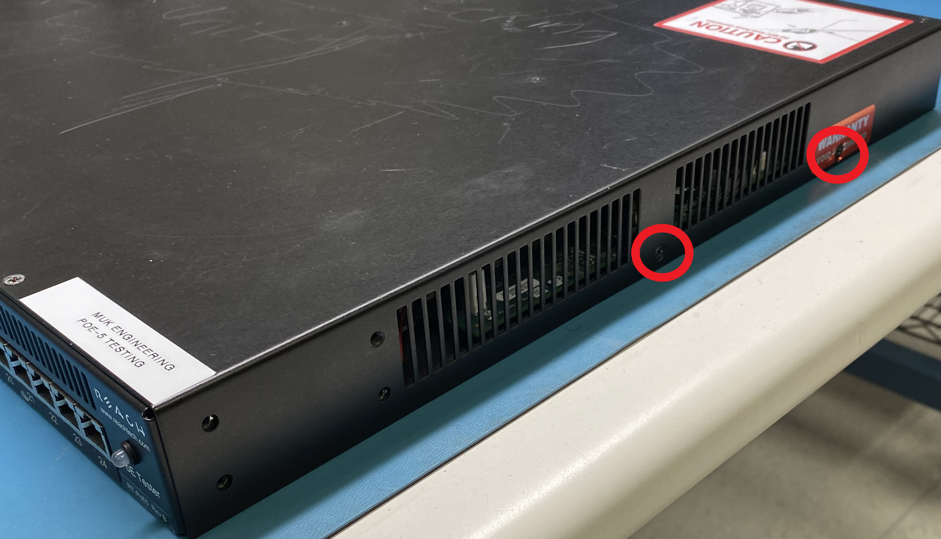
Picture 6.2 Right Side Cover Screw Locations

Remove the 2 screws (PN: 22-0126-00) from the left side of the top cover shown in Picture 6.3.

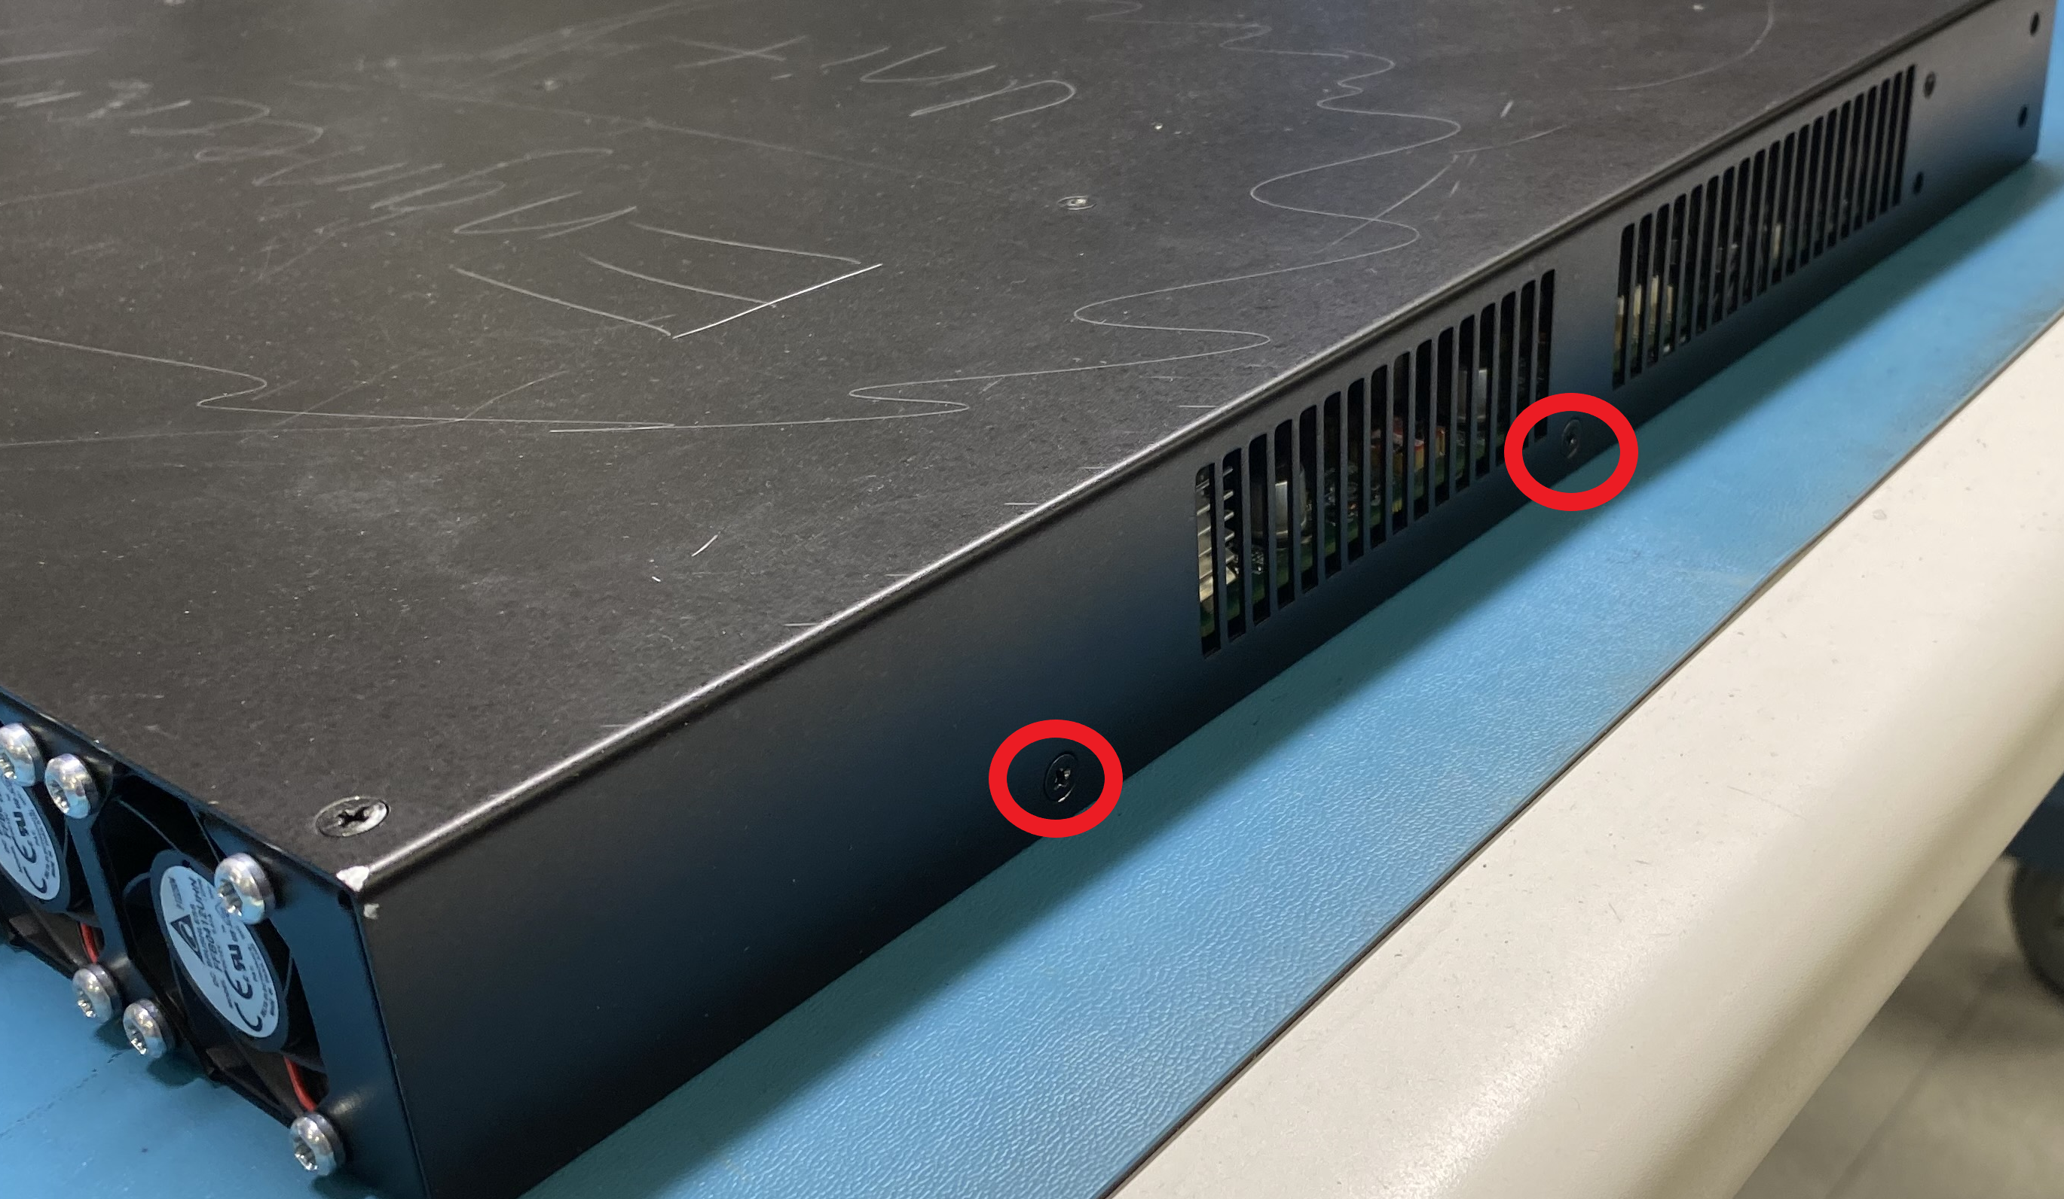
Picture 6.3 Left Side Cover Screw Locations

Carefully lift the top cover up and set aside. If any of the standoffs for the top cover loosened during removing the top cover, ensure they get hand tightened before continuing. Picture 6.4 shows the 3 standoffs to ensure are securely threaded into the bottom cover.

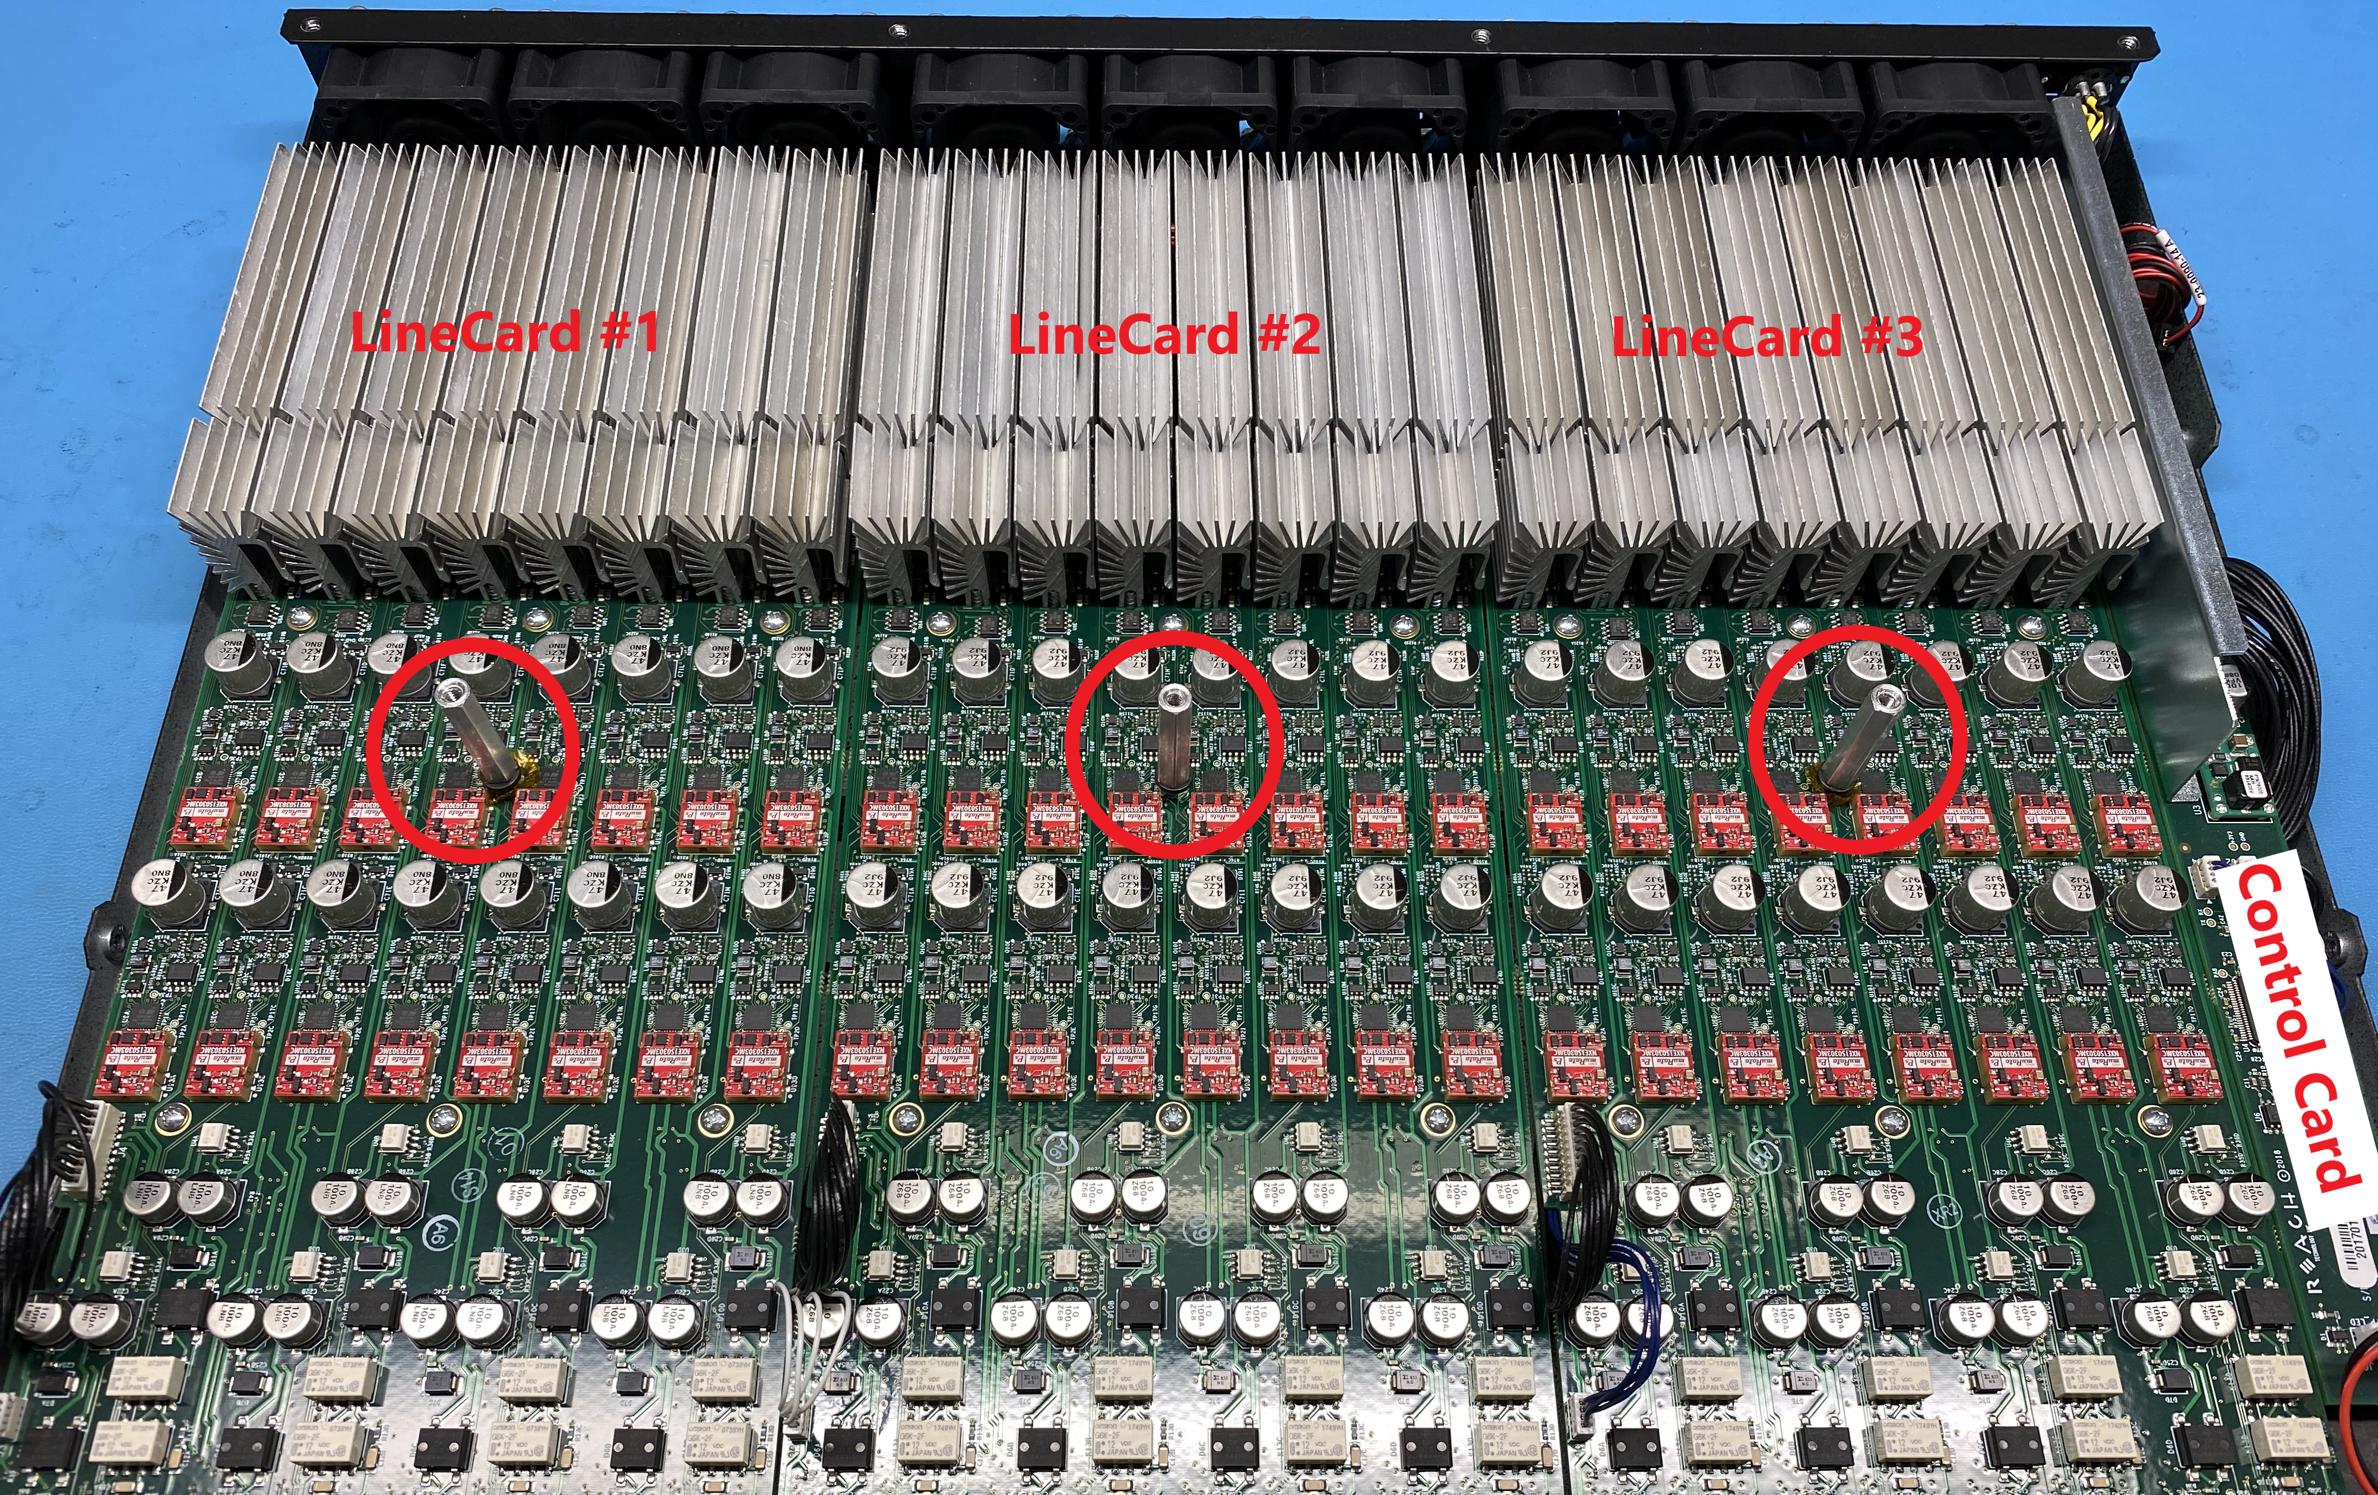
Picture 6.4 Cover Standoffs and Card Locations

Marking the Line Card Cables
There are 3 black wire bundles connected to “J7-9” on the Control Card. Use a black marker to mark the connector in the “J7” location. Use a red marker to mark the connector in the “J9” location. Picture 6.5 is shown as reference. These marks will be used when reinstalling the new Control Card later in the procedure.

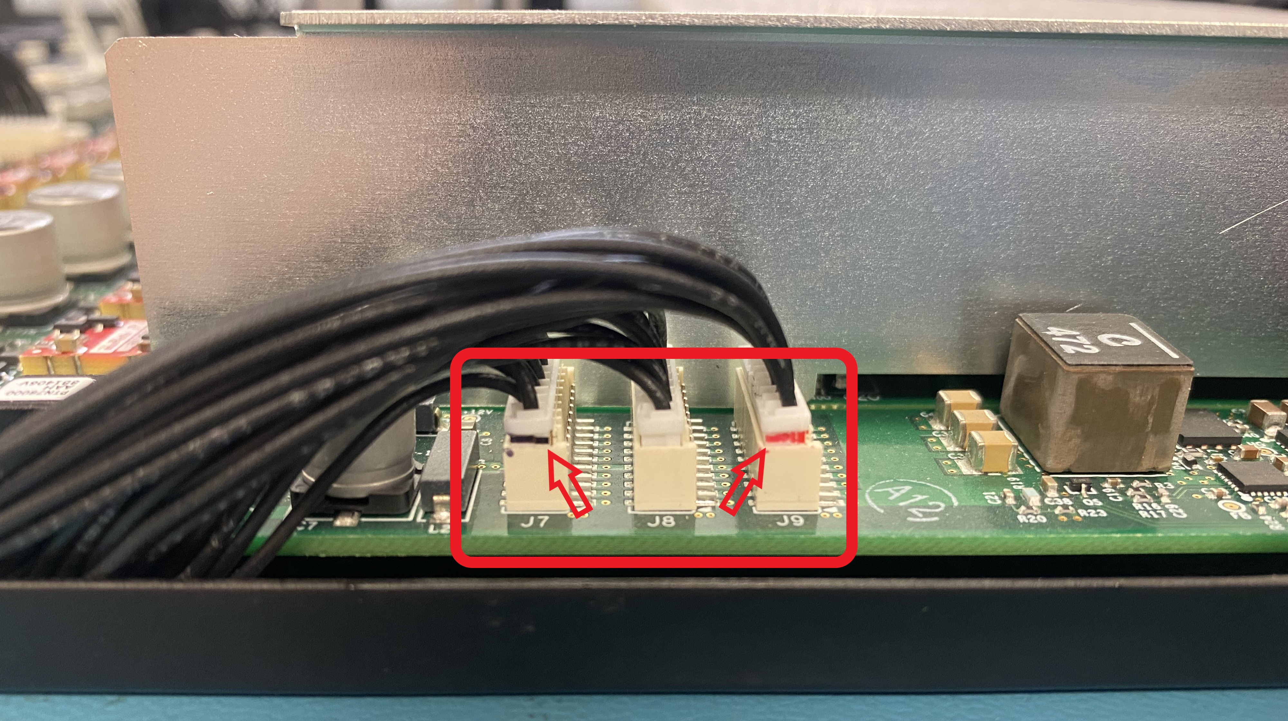
Picture 6.5 Line Card Cable Marking Locations

Disconnecting the Control Card Cables

Disconnect each of the cables from the Control Card shown in Picture 6.6.

WARNING – Use caution when uninstalling connectors near the sheet metal baffle plate between the Line Card and Control Card.

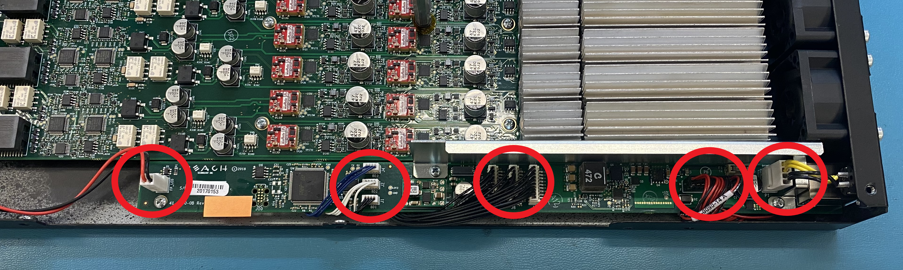
Picture 6.6 Control Card Connector Locations

Removing the Control Card Screws

Use a #1 Phillips Screwdriver to remove the 3 screws (PN: 21-0126-00) holding the sheet metal baffle plate and Control Card shown in Picture 6.7.

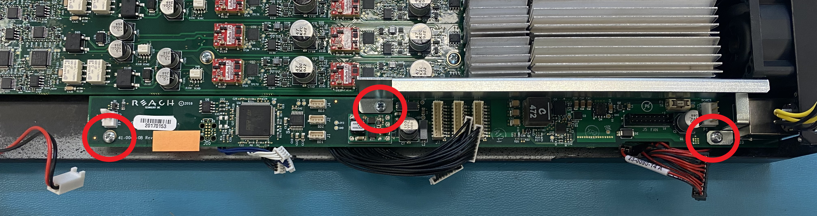
Picture 6.7 Control Card Screw Locations

Remove the sheet metal baffle plate and then remove the Control Card by gently sliding the rear Ethernet port toward the front of the chassis. Direction reference is shown in Picture 6.8.

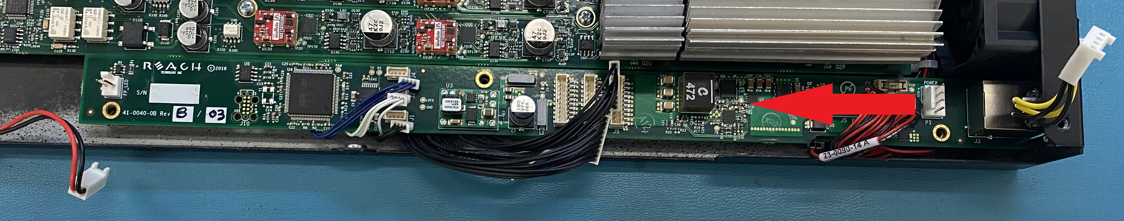
Picture 6.8 Control Card Removal Direction

Inserting the Revision “B” Control Card

Insert the upgrade kit Revision “B/03” Control Card (PN: 41-0040-0B Rev “B/03”) into the chassis shown in Picture 6.9 and carefully slide the Ethernet connector into the rear opening shown in Picture 6.10.

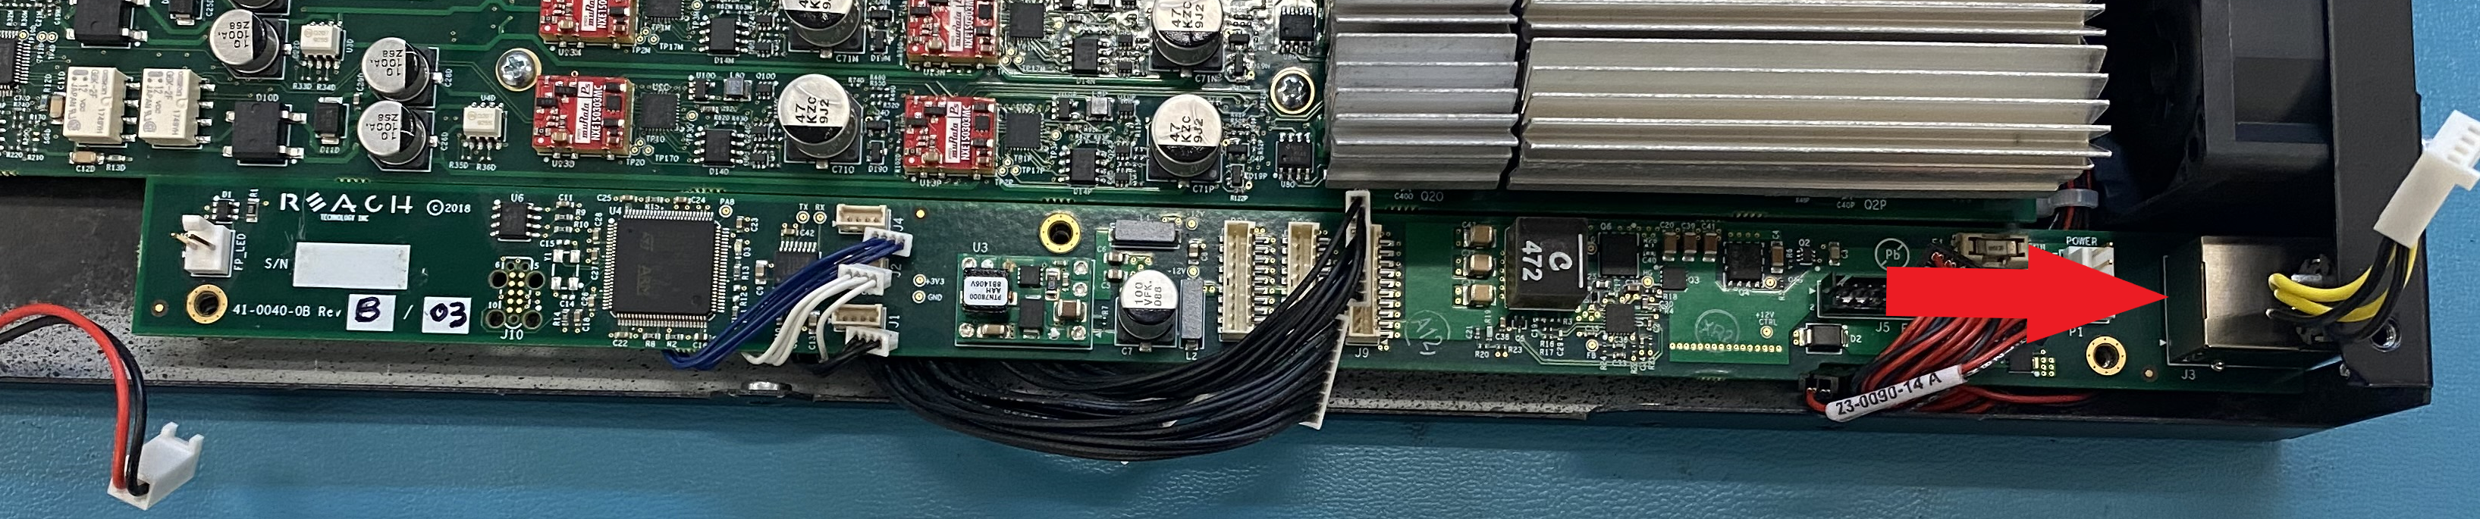
Picture 6.9 Installing the New Control Card

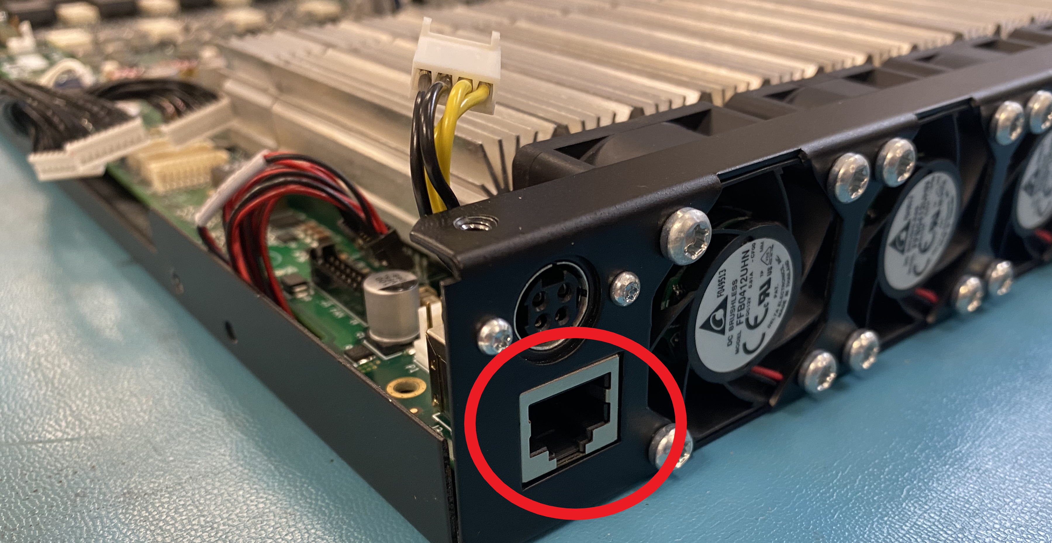
Picture 6.10 Ethernet Connector Positioning

Installing the Baffle Plate

Reinstall the baffle plate and install the 3 screws with 2 in-lb (PN: 21-0126-00) to secure the baffle plate and Control Card to the PoE5 chassis. Picture 6.11 is shown for reference.

WARNING – Ensure all connectors and wires are not pinched when tightening the 3 screws.

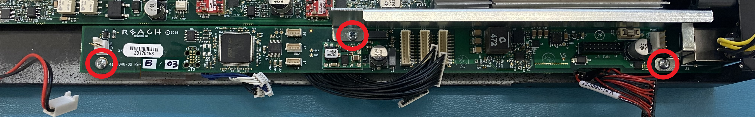
Picture 6.11 Baffle Plate and Control Card Screw Locations

Connecting the Cables

WARNING –Do not use excessive force when inserting cables into their connectors. Each connector can only be installed correctly in one direction. Improper installation may result in damaged connectors or damaged electrical components.

Connect the 2-pin LED Cable to the “FP_LED” location on the Control Card. Connect the 18-pin Fan Cable to the “Fan J5” location on the Control Card. Connect the 4-pin Power Cable to the “P1” location on the Control Card. All locations shown in Picture 6.12.

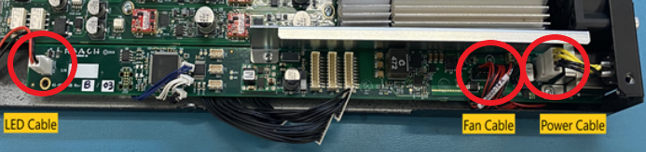
Picture 6.12 Fan, LED, and PWR Connection Locations

Connect the three 4-pin Line Card cables to the Control Card. The black 4-pin cable connects to “BD1” or “J1” location. The white 4-pin cable connects to the “BD2” or “J2” location. The blue 4-pin cable connects to the “BD3” or “J4” location. Picture 6.13 shown for reference.

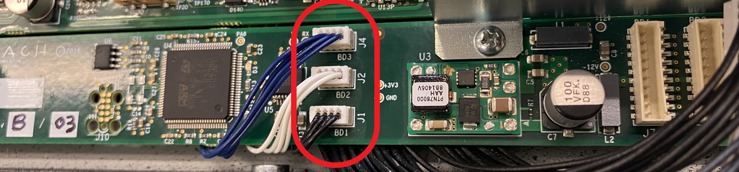
Picture 6.13 Line Card 4-pin Cable Locations

Connect the 10-pin Line Card cable with the BLACK marking to the “J7” location. Connect the 10-pin UNMARKED cable to the “J8” location. Connect the 10-pin RED cable to the “J9” location. Picture 6.14 shown for reference.

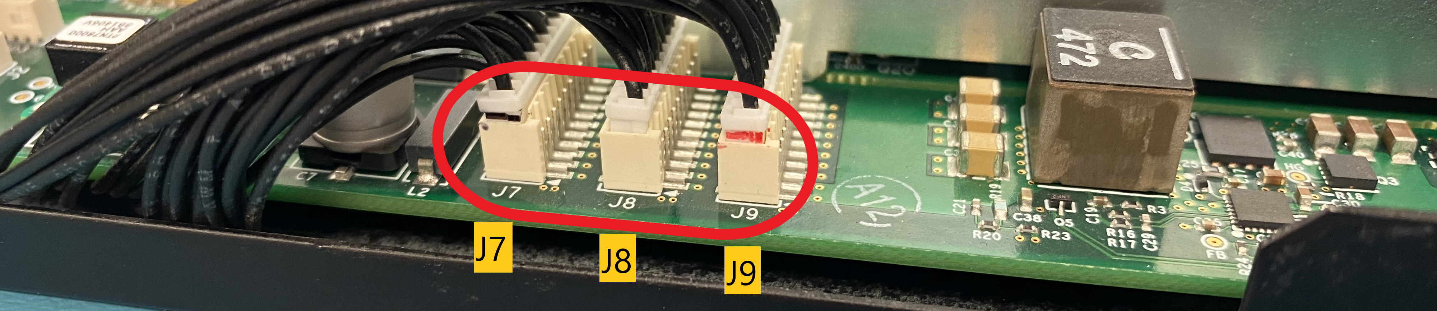
Picture 6.14 Line Card 10-pin Cable Locations

Installing the Top Cover

Place the top cover on the unit with the four screw locations toward the rear of the unit. Use a #1 Phillips Screwdriver to install the 10 screws (PN: 22-0126-00) into the top of the unit shown in Picture 6.15.

Picture 6.15 Top Cover Screw Locations

Install 2 more screws (PN: 22-0126-00) into the right side of the top cover shown in Picture 6.16.

Picture 6.16 Right Side Cover Screw Locations
Install the remaining 2 screws (PN: 22-0126-00) into the left side of the top cover shown in Picture 6.17.

Picture 6.17 Left Side Cover Screw Locations

